CarryBee – Product Analysis
Name: Akib Rahman
Phone: 01534363363
Email: rahmanakib03@gmail.com

Task 1: Merchant Experience Improvement

- Merchant Pain Points:
Here are the key merchant pain points based on the scenario of slow, repetitive manual order creation-
- Repetitive Data Entry: In some cases, like common products, same customer, merchant may require to enter data repetitively which can cause frustration, cost extra time etc.
- Possibilities of Error: Manual inputs can cause mistakes of important information, wrong item selection, pricing mistake etc.
- Time Consuming: Merchants may face more times to input data manually every time.
- Data Reuse Problems: The system will not leverage previous customer data, saved personal information, previous ordered details etc. This is inefficient.

- MVP Solution:
The goal is to develop an OCR order system where merchants can enter images of screenshots or orders to auto fill order details. The MVP solution can be –
- Image Upload Option: An option or button named ‘Enter Image’ and a button named ‘Create order from image’ should be implemented.
- OCR Processing: Take name, number, address etc. using the OCR engine and store them.
- Prepare a Filled Form: After the processing a filled-up form should appear which must be editable because some mistakes can be seen.
- Confirmation Button: Merchant can edit the form or let it as it is and click ‘Confirm Order’ button to confirm the order.
** This system should track the previous records of same customers and their details. An auto suggests entries for the form fill-up.

- User flow:
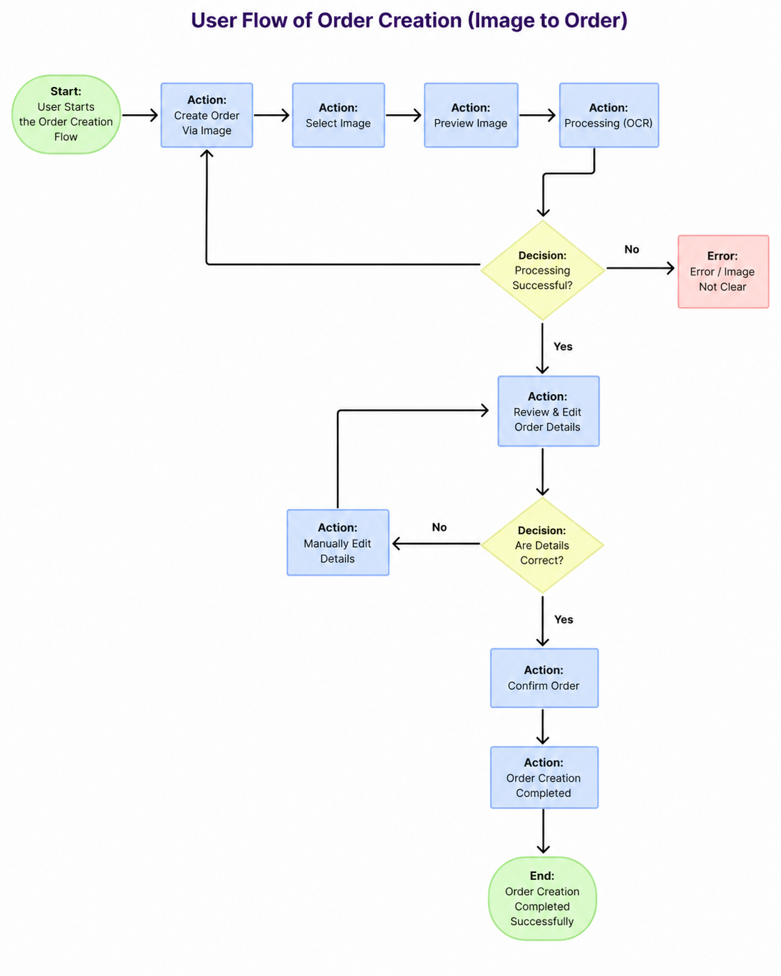

- Three Success Metrics:
Here are 3 clear, high-impact success metrics for the OCR Order Creation MVP -
- Time Efficiency: Metric – average time to create and order, Goal – reduce time of order creation than before.
- Data Accuracy: Metric – Percentages of data correctly filled-up, Goal – Minimum 90% of data correctly extracted from the image.
- OCR Useful Rate: Metric – Percentages of orders creating using the OCR, Goal – Minimum 50% order should be created using OCR.

Task 2: Merchant Feature User Stories

- Order Update:

Title: Merchant receives notifications for order updates.

As a merchant, I would like to be notified in real time when an order is updated,
so that I may effectively handle my orders and act promptly.

Acceptance Criteria –
- Notification Pop-up: When there’s an update for an order available then a notification should come like order placed, order completed, order canceled etc.
- Notification Timing: Notification should come instantly whenever an update is available.
- Notification Contents: Notification should contain order id / name, status etc.
- Read / Unread status: Merchant can check if a notification is read or unread.
- Notification Channels: Notifications should be received via in app or push notification.
Priority: High.

- Payment update:

Title: Merchant receives notifications for payment updates.

As a merchant I would like to be informed if there is an update regarding an order's payment, so that I may precisely manage my finances, track payments, and confirm transactions.

Acceptance Criteria –
- Notification Pop-up: When there’s a payment related update for an order available then a notification should come like payment completed, payment failed, payment received etc.
- Notification Timing: Notification should come instantly whenever an update regarding payment is available.
- Notification Contents: Notification should contain order id, payment status, amount, payment method etc.
- Read / Unread status: Merchant can check if a notification is read or unread.
- Notification Channels: Notifications should be received via in app or push notification.
Priority: High.

- Delivery Delay:

Title: Merchant receives notifications for delivery delays.

As a merchant, I would like to be informed if a delivery is delayed,
in order for me to be proactive, educate clients, and control expectations.

Acceptance Criteria –
- Notification Pop-up: When delivery exceeds estimated time or rider reports delay or other issue for a delay then a notification should come.
- Notification Timing: Notification should come instantly whenever a delay regarding order delivery.
- Notification Contents: Notification should contain order id, delay reason, new estimated time etc.
- Read / Unread status: Merchant can check if n notification is read or unread.
- Notification Channels: Notifications should be received via in app or push notification.
Priority: Medium - High.

- Failed Delivery:

Title: Merchant receives notifications for a failed delivery.

As a merchant, I would like to be informed if a delivery attempt is unsuccessful.
in order for me to take necessary action (such as contacting the client, rescheduling, or canceling the transaction).

Acceptance Criteria –
- Notification Pop-up: When a delivery fails due to wrong address, customer not taking product, rider side problem etc. then a notification should come.
- Notification Timing: Notification should come instantly whenever a delivery failure is reported.
- Notification Contents: Notification should contain order id, failure reason, rider’s note etc.
- Additional Options: Notification should contain options like contact rider, re-request delivery, cancel order.
- Read / Unread status: Merchant can check if n notification is read or unread.
- Notification Channels: Notifications should be received via in app or push notification.
Priority: High.

- Promotional Notification:

Title: Merchant receives promotional notifications.

As a merchant, I would like to be notified about campaigns and promotional updates.
so that I can expand my business and take advantage of marketing opportunities.

Acceptance Criteria –
- Notification Pop-up: A notification should come when there’s any discount or offers available, any special promotions available, new promotional campaigns are launched etc.
- Notification Timing: Notification should come instantly whenever a new promotion is available.
- Notification Contents: Notification should contain title, details about the promotion, expiry date, check or avail option.
- Read / Unread status: Merchant can check if n notification is read or unread.
- Notification Channels: Notifications should be received via in app or push notification.
- Additional Options: Notification should contain options like redirect to campaign page, check promotion details etc.

Priority: Medium.

Task 3: Operations Problem Solving

CarryBee Operations team is struggling with “Trackless Parcels” - shipments that, because of missing, irregular, or delayed status data, cannot be reliably traced while in transit. Customer complaints, operational uncertainty, delayed issue resolution, and an increase in support workload are the results of this.

- Possible Root Causes:
- Parcel Labeling Issue: Incorrect information, damaged QR code, IDs duplication etc.
- Missing Checkpoint Scans: Parcels are not scanned at pickup, hub transfer, or delivery stages because of - rider’s mistake, scanning problem etc.
- Operation lacking: Gap of communication, mistake in tracking of high-volume parcels, parcel status update negligence.
- Human Mistakes: Wrong parcel scan, missing out of any parcel, parcel send to wrong information.

- A Simple Feature to Fix the Problem:
A simple feature can be ‘Checkpoint Missing Notification’.
Feature -
Every parcel goes through some checkpoints like pickup – hub arrival – hub departure – assigned to rider – out for delivery – delivered. If a parcel misses a checkpoint, then a missing notification should be sent to the rider, supervisor and operation team. Also, flag the parcel as ‘Parcel at Risk’.

- Which Users Are Involved: Users that are included –
- Assigned Rider: Scanning parcel at each checkpoint, gets alert if checkpoint scanning misses out.
- Operation Team: Monitor flagged parcels, resolve the issue.
- Customer Support Team: Address or answer issue to the customer.
- Hub Operators: Track parcel status, handle parcel dispatch etc.
- Customers and Merchants: Support seamless process.

- Expected Impact:
- Business Impact: Lower cost for issue solving, improved delivery process.
- Customer Experience Impact: Improved customer satisfactions, lower complaints, better customer experience.
- Operational Impact: Faster issue solving, lower trackless parcels, better recovery rate.

Task 4: Prioritization Exercise

Sprint (Now)
- Fraud Checker (Merchant Side):
Why now –
- Avoids problems later on, such as chargebacks or refund disputes.
- Protects platform trust and revenue early.
- Both merchants and operations teams gain from cross-cutting.

- Reverse Pickup (Operations Side):
Why now –
- permits the flow of necessary refunds, which is a crucial expectation for both consumers and retailers.
- Reduces manual operational load and support tickets.

- Tracking Microsite (Merchant Side):
Why now –
- This is the most effective way to reduce "Where Is My Order?".
- Lowers the customer support load on both the merchant and the operations team.

Later:
- Online Payment on Delivery (Merchant Side):
Why later –
- Cash on delivery already available so it is not on high priority now.
- Fraud control requires to establish online payment.

- Issue Resolution Panel (Operations Side):
Why later –
- Issues can be solved via manual communication in early stages.
- More useful once returns and fraud systems are active.

- Agent Commission Management (Operations Side):
Why later -
- This can be handled via manual exports and spreadsheets in early stages.
- Can be postponed until transaction and operation flows are stabilized.

